MIS779 Portfolio AT2

ANALYSIS ON CREATIVITY AUSTRALIA





**Unit Chair**

**Dr Scott Salzman**

**Group 6**

**Mentor: Dr. Mina Roshan Kokabha**

**Team members**:

Anirudh Asapu: 219419138

Claire Wan: 217614144

Muqi Shao: 218613579

Saurav Lalwani: 219572734

Shruthipriya Ghanathey: 219557848

Van Hoang Nam Nguyen: 219350314

Table of Contents

Executive Summary 3

Introduction and Approach 4

Assumptions 4

Data Cleaning 4

Exploratory analysis 5

Advanced analysis 12

Interpretation 22

Recommendations 23

General Analytics Issues 23

References 24

Appendices 25

# Executive Summary

Creativity Australia is a charitable organization founded by notable social entrepreneur and opera singer, Tania de Jong AM (Member of the Order of Australia). It was found with the intention of creating a happier, healthier and an all-inclusive nation through their popular With One Voice program.

Their main objective is to help people suffering from loneliness and depression by involving them in community singing and choir. This helps people come forward and enjoy the many benefits of being part of a choir along with networking with different kinds of people and gaining mental support. Creativity Australia operates in all major territories of Australia and caters to over 6000 participants aged 9 and above and belonging to all walks of life. They have been doing this and more for the past 11 years through their 35+ different programs organized by hundreds of volunteers all over the nation.

In the process of exploring Question 1, the focus of this advanced analysis is to further analyse the "factors that effectively reduce anxiety." Because the results of the members are ordinal, ordinal logistic regression is performed using in SPSS tool. It was found that "making friends" and "providing an inclusive community" have a greater influence on members' anxiety reduction.

Regarding the conductor’s experience, the important findings were, Firstly, respondents of the choir love sessions with participation of a mix of conductors. Secondly, while there is an increase in neutral comments, the figure for positive opinion decreased slightly. To improve positive opinions, WOV can improve the characteristics of the programs such as the variety of songs, favourite equipment for singing and duration of each performance. Importantly, Internet connection should also be improved, which can affect the experience directly.

Based on the advanced analytics performed on the dataset of 2019 and 2021 to understand people’s opinion on weekly choir, it was found that choir members in the year 2021 are estimated to have a lower negative opinion and higher neutral opinion on the choir compared to the year 2019 and moreover, people have shown considerate liking towards conductor Dillon.

When trying to improve ‘customer experience’ with the help of survey data, we found the senior females takes the largest customer group and we recommend WOV to do another survey to learn people’s preference of songs in different age and gender. Thus, customers’ need can be satisfied better. And WOV can set the choir time based on the suitable time for most customers , which is found to be Tuesday.

As far as utilising the survey data for promotions, based on exploration, it is evident that Creativity Australia is already having its active social media presence with conducting various online activities. However, upon further performing advanced data analytics, it was found that the choir members, expressed interest in receiving regular updates from the choir, like timely newsletters through emails, reminders about upcoming events through text messages and more engagement on the already active social media platforms, especially Facebook.

Moreover, on further exploration on the support provided by the head office over the years, it is identified that there is a significant trend or pattern that could possibly impact the overall rating provided by choir members. Upon performing advanced analysis, it was found that the support provided by head office has not improved over the years and it is recommended that creativity Australia improve their customer experience by developing strategies.

# 

# Introduction and Approach

In modern society, about 2 out of 5 people feel socially isolated and unheard. "Creativity Australia" hopes to help bridge the gap between people who feel lonely and those who are more fortunate by singing. It is hoped that through the “With One Voice" project, the community will be more cohesive.

The purpose of this report is to perform an advanced analysis on the business problem of the creativity Australia using the provided dataset to test the hypothesis provided previously and suggest actionable recommendations for implementation. To perform these tasks, we have used some efficient analytical methods such as sentiment analysis, Topic modelling, Clustering models, multiple logistic regression analysis, Bayesian Analysis with the help of tools, python, Excel, RapidMiner and SPSS.

# Assumptions

Below are the assumptions taken for performing Advanced Analytics

* Although the sample size is different for all the years survey responses, it is assumed that they represent the opinion of overall members of the choir.
* The survey responses are assumed to be accurate, and appropriately represent the opinion of all the members of the choir.
* Survey responses have been assumed to be unbiased and represent the true feelings of the choir members.

# Data Cleaning

The below Steps are taken to perform cleaning on the dataset, based on the techniques:

**Text Analytics:**

* For the text analytics, the missing values, punctuations, numbers, special characters are removed
* Stop words removed based on the relevance.
* During Topic modelling only nouns are considered, with tokenizing, lemmatization
* Words with only length > 3 are considered for modelling.

**Building cluster models:**

* Filter out some superfluous attributes, just reserve the attributes we need
* Choosing examples with not missing values
* Transfer the nominal attributes to numerical
* Normalize the data using range transformation

# Exploratory analysis

**Q.1. What do the choir members indicate as their primary benefits of being involved?**

**Has this changed over the years?**

Upon exploring the survey dataset to find the benefits of the choir it was found that there are five main benefits, namely reducing stress, reducing anxiety, making new friends, practicing English, and increasing self-confidence.

In the processing, there was observed a certain relationship between "reducing anxiety" and other factors which was interesting, which led to analysis to determine which factors are more weighted. Therefore, this part selects some attributes as influencing factors to research "effectively reduce anxiety in the choir", including "less stress, make new friends, improve English skills, increase self-confidence, an inclusive and supportive community, and feel happy for a total of six the impact of potential influencing factors on the level of satisfaction. Therefore, based on the observations, we have the below hypothesis.

**Hypothesis:** Making new friends can effectively reduce anxiety in the choir.

There are five level of satisfaction, which are "Strongly Agree”, "Agree ", " Neither agree, or disagree ", " Disagree ", "Strongly Disagree", they are converted to numerical as shown in the figure 1.1 below. Since Y is nominal data and ordinal, it is suitable for Ordinal logistic regression. It is analyzed in the software SPSS tool.

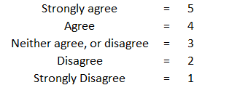

***Figure1.1: standard exchanging***

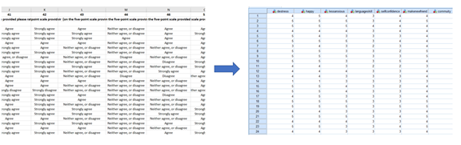

***Figure1.2: the data pre-processing***

**Q2) How do you see the conductor?**

Based on the exploratory analysis on the year 2020, on people’s preference on the type of conductor session, it can be seen that from the below chart, a mix of conductors from all over Australia session is prefer to just my own conductor.

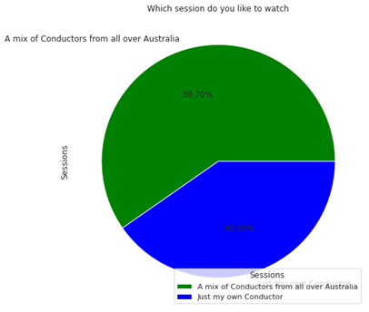

***Figure 2.1: Which session do you like to watch in 2020***

Therefore, based on the above chart, and exploratory analysis performed over years as shown in **appendix 2.1a**, from the previous assignment part, the below hypothesis is derived:

**Hypothesis:** Members of the choir during Covid-19 are estimated to give lower positive opinions and higher neutral opinions of the conductor before Covid-19.

To verify the hypothesis, we are using sentiment analysis

**Sentiment analysis:**

Sentiment analysis is an essentials method for business to gauge customers response to products and services.

Customers usually talk about products on social media, customers’s feedback forums and data surveys. We will divide our questions into two stages: before Covid-19 and during Covid-19.

The first thing is that we analyze the sentiment analysis through choir members’ feedback of conductors through the following questions:

**“Are there any other comments you would like to make about the value of the Choir to you?”**

**“Do you have any feedback for us about our live sessions?”**

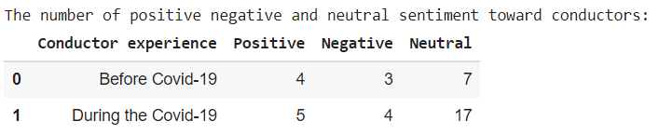

***Figure 2.2: The number of positive, negative and neutral sentiment toward conductors***

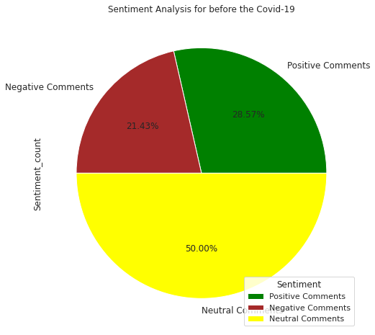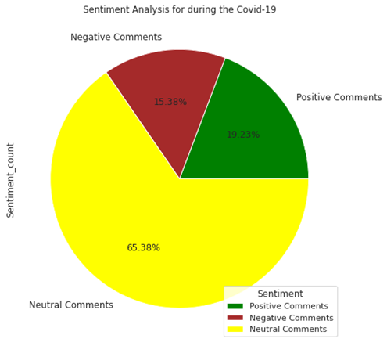

***Figure 2.3: The proportion of positive, negative, and neutral sentiment toward conductors***

As can be seen from the figure above, to compare the figures before and during the Covid-19 pandemic, there are more neutral opinions during the Covid-19 pandemic than before Covid-19. By contrast there is a decrease in positive opinion. While there is an increase in neutral sentiment from 50% to 65.38%, there is a decrease in positive sentiment from 28.57% to 19.23%.

Therefore, based on this outcome of analysis, the claim made is True.

i.e., The claim of **“members of the choir during Covid-19 pandemic are estimated to give lower positive opinions and higher neutral opinions of the conductor before Covid-19 pandemic” is** TRUE.

**Q3. How do people view their weekly ‘choir’ experience?**

Based on the exploratory analysis performed on this business problem from the years 2019 and 2021, it has been hypothesized that,

**Hypothesis: Choir members in the year 2021 are estimated to have a lower negative opinion and higher neutral opinion on the choir compared to the year 2019.**

To verify this claim, we are performing advanced analytics to gain people’s sentiments about the choir from the years 2019 and 2021.

The responses to the below questions were used:

**2019:**

* Is there anything that you particularly like about the choir?
* Is there anything that you particularly dislike about the choir?

**2021:**

* What is the best thing about the choir?
* Is there anything your particularly dislike about the choir?

By developing a sentiment analysis model, we have derived the sentiment score for each provided member response and categorized their opinion on choir with the derived score, based on a threshold of 0.3 as Positive, Negative or Neutral.

Below is the visualization of the derived sentiment of people in the year 2019 and 2021:

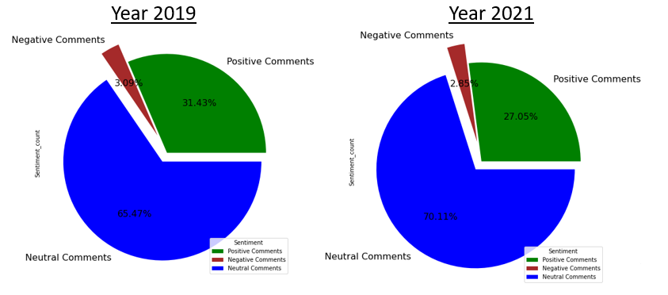

***Fig3.1: Sentiment Analysis of choir members in the year 2019 and 2021.***

From the above chart, it can be seen that in the year 2019 and 2021, majority of the choir members have a neutral opinion on the choir. Moreover, it can be seen that the neutral opinion has increased from 65.47% in 2019 to 70.11% in 2021.

Looking at the negative sentiment of choir members, it can be said that it is decreased from 3.09% in the year 2019 to 2.85% in the year 2021.and moreover, the positive sentiment is also observed to decrease from 31.43% in the year 2019 to 27.05% in the year 2021.

Therefore, based on this outcome of analysis, the claim made is True.

i.e., The claim of “**choir members in the year 2021 are estimated to have a lower negative opinion and higher neutral opinion on the choir compared to the year 2019” is** TRUE.

**Q4) How can the survey help our ‘customer experience’?**

**Hypothesis: The choice of the songs and the day of conducting the choir will influence people’s experience on the choir.**

To verify this claim, we have done some text mining work and got the outputs:

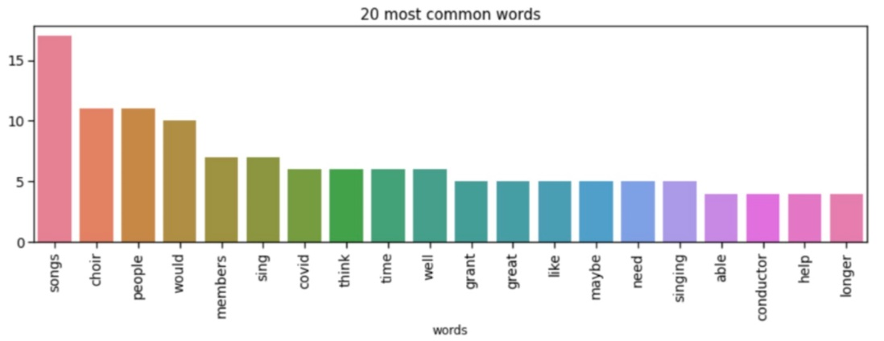

***Figure 4.1: Top words in people’s feedback for improvement in choir***

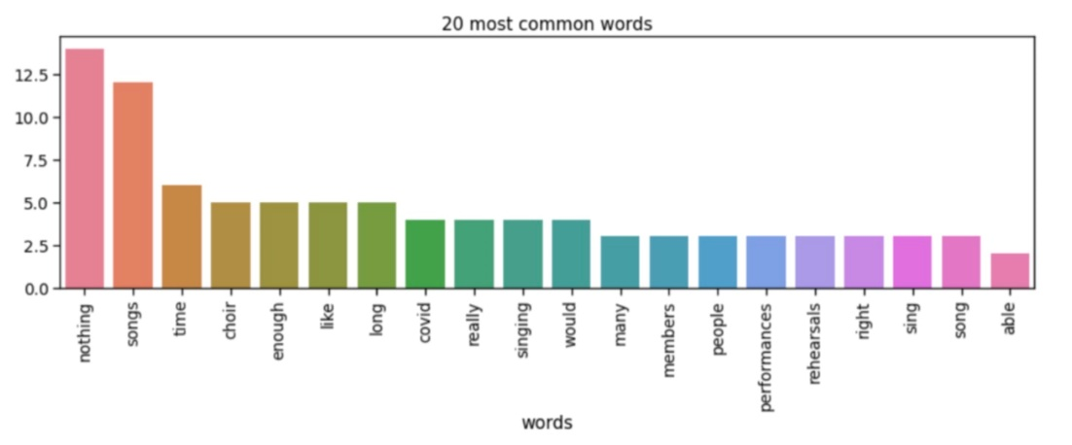

***Figure 4.2: Top words in people’s feedback for dislike about the choir***

We can see form these two figures that a lot of people are satisfied with the choir and have no dislikes about the choir. But songs and time still takes a large part in people’s dislikes about the choir. This proves WOV needs to improve the song list and time setting.

I plan to take clustering analysis and cluster models to:

1.Grouping the customers to learn the major customer group of WOV.

2.Predicting people’s preference songs according to their age and gender.

3.Making sure which time is beat suitable for customers.

**Q5. How can the survey assist Creativity Australia in our promotions?**

With regards to marketing and promotion of Creativity Australia, the survey data contains a limited amount of data for us to analyze. However, to find out better ways in which CA can use the survey data for promotions and for our initial analysis purposes we have considered the following attributes:

**2018:**

1. How can we communicate with you better? What would you like to hear more or less of?
2. How did you hear about your choir?

**2021:**

1. How did you first hear about WOV choirs?
2. How can we communicate with you better?

Based on the analysis, we have proposed the below hypothesis:

**Hypothesis:** People are reacting in a positive way towards the promotion undertaken by Creativity Australia. They have shown more interest to communicate better.

To verify the hypothesis, Sentiment Analysis has been done in **Figure 5.1** which has been included in the appendix to determine the level of positive and negative sentiments in the survey data regarding communication and related preferences of participants at the WOV. Using RapidMiner we have visualized it on pie charts for the years 2018 and 2021.

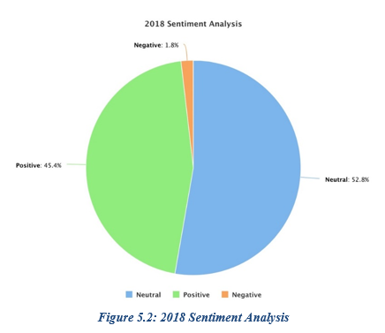 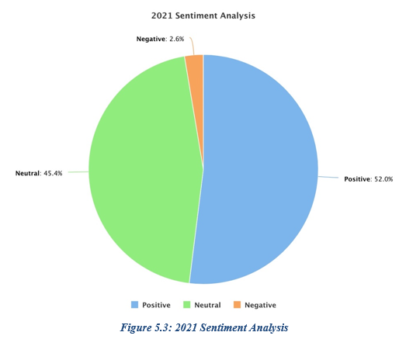

We can see from the pie charts above that the number of positive comments has increased from 45.4% in 2018 to 52% in 2021. The negative comments on the other hand have also had an increase from 1.8% in 2018 to 2.6% in 2021. In terms of the neutral comments, we can see that they have reduced from 52.8% in 2018 to 45.4% in 2021.

Therefore, based on the outcome of the analysis, the hypothesis made is True.

**Q6. How do people see the support provided by the head office? Has this changed?**

Based on the exploratory analysis performed in assignment 1, the below hypothesis is proposed:

**Hypothesis:**

H0: the support of the head office has not improved over the span of two years.

H1: the support of the head office has improved over the span of two years.

**Modelling using SPSS:**

From our preliminary analysis we have derived time series graphs for the year 2019 and 2021.A multiplicative model is observed on the time series data for two years 2019 (June & November) and 2021, a surge in seasonality and variations can be observed when there is a rise in the level of trend. We thus decompose the data over the period of two years and draw residuals by eliminating components of trend and seasonality.

By using Linear regression in SPSS, we can draw residual graph for further analysis:

***Figure 6.1: Histogram of residual analysis. Figure 6.2: Q-Q plot of residual analysis***

***Figure 6.3: Histogram of residual analysis for the year 2021 Figure 6.4: Q-Q plot of residual analysis for the year 2021***

Normality of the data set can be derived through Q-Q plot as they are statically ubiquitous. From the Q-Q plot we can conclude that the data over the period two years are normally distributed.

# Advanced analysis

**1. What do the choir members indicate as their primary benefits of being involved?**

**Has this changed over the years?**

**Hypothesis:** Making new friends can effectively reduce anxiety in the choir.

The independent variable X is set to six factors, namely "less stress, make new friends, improve English skills, increase self-confidence, an inclusive and supportive community, and feel happy. The dependent variable Y is set to "less anxiety". In SPSS's multiple logistic regression analysis. (Details are shown in figure1.1 below)

Firstly, check the "Model Fitting Information", the significance level is 0.005 less than 0.05. It means that the model is meaningful. Continue to check the table of significance level of "Likelihood Ratio Tests". We found that some independent variables have a significance level greater than 0.05, so we can further adjust the model and delete these independent variables.

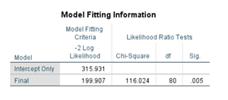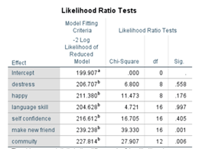

***Figure1.1: the result of Significant of Modeling***

Secondly, repeat the above steps and reselect the independent variable parameters. Only select "making new friends" and "community " in this configuration, then check the table "Model Fitting Information". The significance level = 0.002 is less than before. This proves that the optimized model has more reference significance.

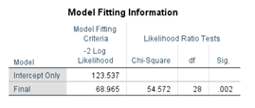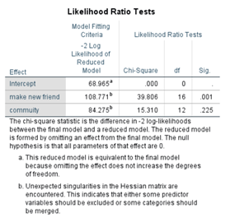

***Figure1.2: the optimized modeling***

**Q2) How do you see the conductor's experience?**

To understand better customer feedback and improve positive sentiments , we will use LDA topic modelling to gain insight through open- ended questions.

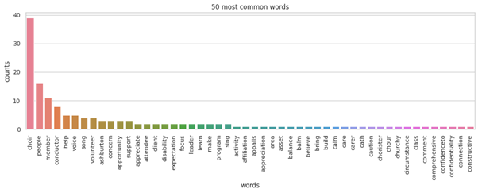

***Figure 2.1: Top 50 most common words before Covid-19***

Before the Covid-19 pandemic, as can be seen from the chart above, the most frequent words include “choir, people, members, and help” that means WOV can improve about the conductor experience by supporting of the conductor, who want to improve their voice.

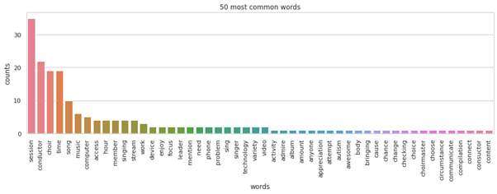

***Figure 2.2: Top 50 most common words during the Covid-19***

During the Covid19 pandemic, as can be seen from the chart above, the most frequent words appearing during the Covid-19 include “session, conductors, choir, time and song”. It indicated that improving the quality of songs in the sessions could be a suggestion to improve the conductor's experience for WOV. In addition, the time of sessions should be considered.

**ii. Topic modelling**

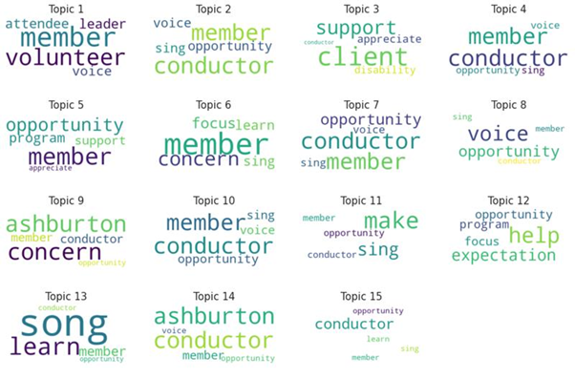

***Figure2.3 : Extract and view the top words in each topic before the Covid-19 pandemic***

As can be seen from the Word Cloud before the Covid-19 pandemic, topic 1, topic 2, topic 4, topic 7, topic 8, topic 10, topic 11 and topic 15 mentioned mostly about the demand of members want to sing with conductors. While topic 3 discusses about the conductor should help disable clients; topic 6, topic 13 indicated about members only want to focus on singing instead of other activities: selling tickets. Next, Ashburton members would want the conductors to help to improve their voices in topic 9 and topic 14. Last but not least, members are looking for the opportunity to interact directly during conductor’s performance in topic 5 and 12.

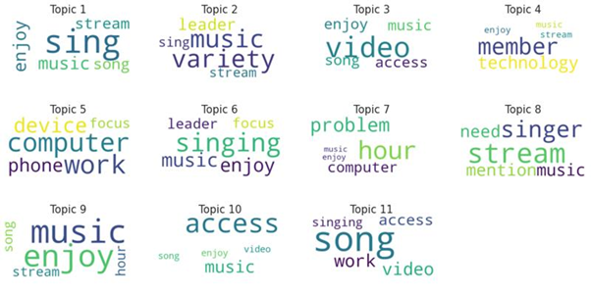

***Figure2.4 : Extract and view the top words in each topic after the Covid-19 pandemic***

As can be seen the Word Cloud during the Covid-19 pandemic, topic 1, topic 2, topic 3, topic 4, topic 6, topic 10 and Topic 11 mentions mostly about members wanting to sing a variety of songs with the conductors on livestream. While the topic 5 discusses about members want to sing songs online through computer device and phone, topic 7 indicates about members mention computer problems, the time of performance of conductors. They want the performance is longer. Next, members want to enjoy the performance with the participation of singers in topic 8. Last but not least, members want to the performance with conductor is longer in topic 9.

In conclusion, comparing to the figure extract and view the top words in each topic before the Covid-19 pandemic, we can see the changes during the Covid-19 pandemic . Similar years before the Covid-19 pandemic, members still want to interact with conductor’s perfomance. However, there are some differences. These changes happen during before and after Covid 19 pandemic hit the world. The global pandemic caused by Covid-19 pandemic presented an unprecedented challenge to our lives. Victoria was a mong the first state in Australia that saw a surge number of infections. Victoria government has implemented various public policies (e.g lockdown, quarrantine) to prevent the spread of the virus among communites.

Therefore, most of activities have been changed to online. As a result, people now mention about the characteristics of the programs such as the variety of songs, favorite equipments for singing and time of each performance. The main problem that they concern about is the Internet connection, which can affect their experience directly.

**Q3. How do people view their weekly ‘choir’ experience?**

**Has this changed over the years?**

From the above exploratory analysis from Q3, it can be highlighted that majority of the choir members are neutral, and they are not having any negative experience of the choir and not positive either. Thus, we can focus on utilizing the strengths of the choir to convert their neutral experience to positive.

Based on an article published by Forbes, which indicates that investing in strength- based strategies is more impactful and rewarding than Weakness-based strategies. They further suggested that enhancing the organization strengths increases employee engagement and increases the overall experience to be more positive

Therefore, we perform further analysis to understand what people like about the choir the most, using the data from the years 2019 and 2021. The member responses to the questions below are analyzed:

**2019:**

* Is there anything that you particularly like about the choir?

**2021:**

* Is there anything that you particularly like about the choir?

Using the advanced analytical method, of Topic modelling using the LDA Genism, we analyze the dataset with using the nouns used by the team members for their likeness about the choir and develop a model for both the years having a coherence score greater than 0.6.

Therefore, based on the best model, we get the below topics for the years 2019 and 2021:

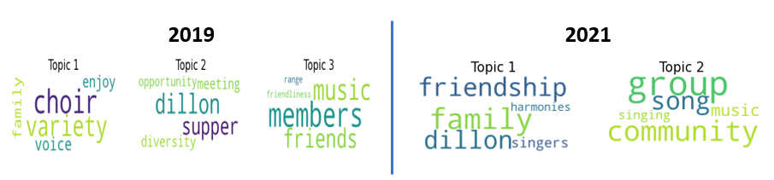

***Figure3.1: Topics derived based on modelling***

In the year 2019, people expressed to like the range of music, making friends with the choir members. The members mentioned to enjoy attending the choir with family and singing with a variety of songs, they also mentioned to like the choir supper, and diversity of the choir and meeting conductor Dillon.

Whereas, in the year 2021, people expressed their likeness for the choir community, and singing harmonies with the group and attending the choir with family, the friendships they made through the choir, and they also mentioned conductor Dillon.

However, apart from enjoying the choir with family and making friends, people have mentioned Dillon in both years. Thus, further analysis is performed to verify what do people think about the conductor Dillon.

The Analysis is done using the data from the years 2019 and 2021, with filtering the responses of the choir members for “what they like about choir” which mentions about Dillon. Similarly, Topic Modelling is used to view the abilities of what standout about conductor Dillon compared to others.

Based on the developed model, we get the below topic:

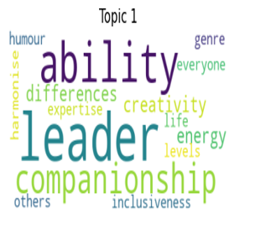

***Fig3.2: Topic derived for conductor Dillon***

The above word cloud visualizes the abilities of conductor Dillon, which are highlighted below:

* Showing leadership qualities and making the choir inclusive for everyone with no differences.
* Having high energy levels and a good sense of humor and creativity than other conductors.
* Providing companionship to everyone in genre of harmonies with expertise.

Thus, these are the qualities which make people like Dillon more compared to the other conductors, which makes her one of the strengths of the choir.

**Q4) How can the survey help our ‘customer experience’?**

With the help of text mining tools, we have analyzed people’s survey answers of dislikes and feedback for WOV. Then we got a summary perspective:

A lot of people are satisfied with the choir and have no dislikes about the choir. But songs and time still take a large part in people’s dislikes about the choir.

Then we have two recommendations for WOV in the first assignment:

1. WOV should choose songs that are more suited for different customer groups.

2. WOV can set the time of choir according to people’s preferences.

To implement the two recommendations, it is necessary to group the customers to learn about the major customer groups of WOV and learn which time is suitable for the most customers of WOV.

Cluster model is suitable for implementing these two processes.

**Grouping the customers by age and gender**

As shorn in lots of surveys, people’s preference of songs is significant different with the change of their age and gender. So, I take age and gender of customers in the 2021 survey data to build a k-means cluster model.

I take k=5 to group customers into 5 groups. Then I get the outputs:

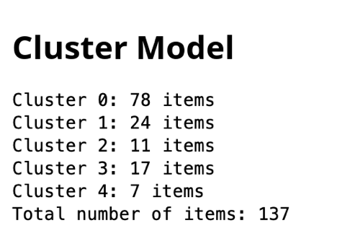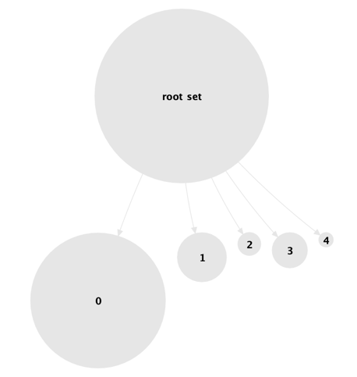

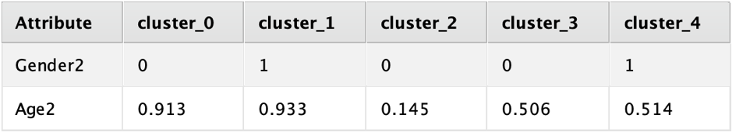

***Figure4.1 Cluster Model of customer groups***

We get 5 clusters which can be generalized as following:

Customers who are females and most of them are 55+ years old; (Senior females)

Customers who are males and most of them are 55+ years old; (Senior males)

Customers who are females and most of them are 25-34 years old; (Young females)

Customers who are females and most of them are 35-54 years old; (Middle-aged females)

Customers who are males and most of them are 35-54 years old. (Middle-aged males)

Cluster_0 is the largest cluster in all clusters. Which means senior females takes the largest part of WOV’s customers.

As we have knew the different groups of WOV’s customers, WOV can implement a supplementary survey or employ some organization to do the survey to learn people’s favorite songs in different age and gender. Then take the ‘favorite song’, ’gender’ and ‘age’ as attributes to do clustering. The new cluster model can be used to predict customers’ preference of songs based on their gender and age.

Thus, WOV can make some reasonable improvement of the choirs’ song list. What is more, it is unquestionable WOV should consider more of senior females’ preferences.

**Grouping customers’ preference of time of choir:**

I take peoples feedbacks of the frequency, weekday, and time length of choirs in the 2021 survey data to build a k-means cluster model.

I take k=5 to group customers into 5 groups. Then I get the outputs:

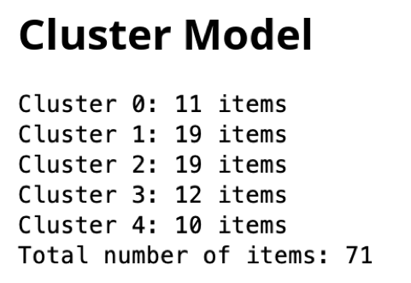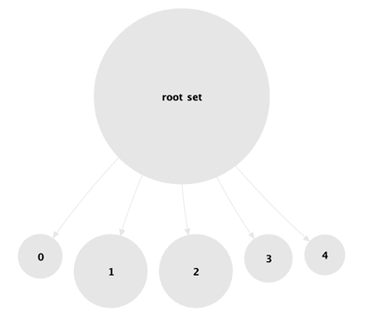

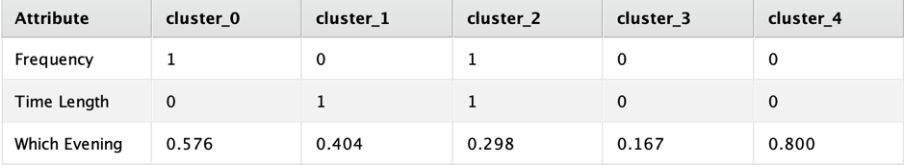

***Figure4.2 Cluster Model for preference of time***

We get 5 clusters which can be generalized as following:

Customers who prefer the choir to be on every Wednesday for half an hour.

Customers who prefer the choir to be on Tuesday fortnightly for an hour.

Customers who prefer the choir to be on every Tuesday for an hour.

Customers who prefer the choir to be on Monday fortnightly for half an hour.

Customers who prefer the choir to be on Thursday fortnightly for half an hour.

Here, Cluster_1 and Cluster_2 are the largest clusters in all clusters. Seems that if WOV sets the choir on Tuesday for one hour in every two weeks or every week, it will be suitable for most customers.

**Q5. How can the survey assist Creativity Australia in our promotions?**

To figure out how and where the survey data can be used for promotions of the WOV program we have undertaken topic modelling using LDA (Latent Dirichlet Allocation) in Python. In this we have selected data from 2018 and 2021 and undertaken basic pre-processing measures like removing punctuations, numbers, special characters, short words, stop-words, etc. We have visualized the 50 most common words for both years as part of the text on a bar graph below:

**Figure 5.4: 2018 50 most common words**

**Figure 5.5: 2021 50 most common words**

After removing the frequent and infrequently occurring words, we use the LDA Gensim package to determine the most frequented topics to determine ways to use the survey data for promotional purposes for our client.

**Figure 5.6: 2018 most frequented topics**

**Figure 5.7: 2021 most frequented topics**

From the above images it can be seen that participants of the survey are mostly discussing emails, Facebook, programs, Wishlist, volunteer, activities, etc., in 2018. In 2021, we can notice topics like media, emails, Facebook, issues, newsletter, etc., being discussed most frequently. On the basis of these topics a few recommendations have been formulated for CA to implement for better usage of the survey data for their promotional activities.

**Q6. How do people see the support provided by the head office? Has this changed?**

* 1. **Hypothesis Testing & Analysis using Means/Independent T-test:**

For hypothesis testing we have used SPSS to conduct Independent two sample t-test on the data set for a period of two years 2019 and 2021.

***Figure 6.5: Hypothesis testing using SPSS***

We have grouped the variables into specific years as seen in the figure

Group1: 2019

Group2: 2021

***Figure: 6.6: grouping variables as per their year of origin***

***Figure 6.7: Group statistics and Independent Sample Test Table***

**Result:**

A brief descriptive statistic has been provided for the year 2019 and 2021. By analyzing the Test Table, we can conclude that means are statically significant as the p value is less than 0.05. Finally, we conclude that there is strong evidence that indicates there is less than 5% probability for null hypothesis to be true. Hence, we reject the null hypothesis.

**1.2 Hypothesis test & Analysis using Bayesian Analysis**:

The t-test on time series analysis can produce overoptimistic results thus we use Causal impact analysis to derive appropriate results.

**Modelling:**

Here we use SPSS to conduct Bayesian analysis using independent sample and group the data into:

Group1 – 2019

Group2 – 2021

***Figure 6.8: Bayesian analysis using independent sample***

***Figure 6.9: Results through Bayesian independent analysis***

**Result:**

The above data provides us the results of Bayesian independent analysis. Descriptive statistics along with Bayes Factor which is 0.010 helps determine the mean likelihood between the null and alternate hypothesis. The Loglikelihood and Posterior graphs are undistinguishable and look alike, the mean difference of rating over the period of two years is 0.28 and the BF is 0.010 which suggests that the null

hypothesis is true.

# Interpretation

**1. What do the choir members indicate as their primary benefits of being involved? Has this changed over the years?**

**Hypothesis:** Making new friends can effectively reduce anxiety in the choir.

The Claim made is True.

**2. How do people see their Conductors? Has this changed?**

**Hypothesis:** Choir members during the Covid-19 are estimated to have a lower positive opinions and higher neutral opinions on the conductor’s experience to compare with figures before the Covid-19 pandemic.

The Claim made is True.

**3. How do people view their weekly ‘choir’ experience?**

**Hypothesis:** Choir members in the year 2021 are estimated to have a lower negative opinion and higher neutral opinion on the choir compared to the year 2019.

The Claim made is True.

**4. How can the survey help our ‘customer experience’?**

**Hypothesis:** The choice of the songs and the day of conducting the choir will influence people’s experience on the choir.

The Claim made is True.

**Q5. How can the survey assist Creativity Australia in our promotions?**

**Hypothesis:** People are reacting in a positive way towards the promotion undertaken by Creativity Australia. They have shown more interest to communicate better.

The claim made is True.

**Q6. How do people see the support provided by the head office? Has this changed?**

**Hypothesis:** The support provided by the head office to the choir members has not improved over the span of two years. The mean ratings for the years 2019 and 2021 are similar.

The claim made is True

# Recommendations

**Q1. What do the choir members indicate as their primary benefits of being involved?**

**Has this changed over the years?**

* Choir could organize more activities or party to increase the influence factor of making friends.

**Q2. How do people see their Conductors? Has this changed?**

* With One Voice should improve the characteristics of the programs such as the variety of songs, favorite equipments for singing and time of each performance.
* With One Voice should improve the Internet connection, which can affect to their experience directly.

**Q3. How do people view their weekly ‘choir’ experience?**

* Increase the frequency of the choirs conducted by the Dillon across all the choir locations. Since people have expressed to like Dillon’s performance. It would help to create positive experience for people towards the choir.
* Dillon can provide training to the conductors to maintain the similar positive experience across all the choirs

**Q4. How can the survey help our ‘customer experience’?**

* I recommend WOV to do a supplementary survey to learn senior females’ favorite songs and do some modifications in their song list for choirs based on this.
* WOV should set the choir on Tuesday for one hour in every two weeks or every week. According to the analysis outcome of cluster model, it is most suitable for WOV’s customers.

**Q5. How can the survey assist Creativity Australia in our promotions?**

* Participants have mentioned about email and newsletters quite frequently which means that they would like the idea of receiving regular newsletters through emails which will keep them in regular touch with Creativity Australia’s ongoing and upcoming activities.
* Creativity Australis can send notifications about events through messages which can act as a last-minute reminder and ensure maximum participation at every CA event.

**Q6. How do people see the support provided by the head office? Has this changed?**

* The main aim should be to improve customer service experience.
* The head office can aim to implement strategic objectives where choir members can sign for a cause – charity.

# General Analytics Issues

* This survey is only used for Creativity Australia's internal analysis, and it is not allowed to be used for profitable communication, publicity, sharing, etc.
* The dataset is confidential and is not shared among anyone across any platforms.
* The dataset does contain multiple analytical issues such as missing data, poor quality of data, missing values, and partial information.

# 

# References

1. Suner, E., 2021. Council Post: Why Leaders Should Focus On Strengths, Not Weaknesses. [online] Forbes. Available at: <https://www.forbes.com/sites/forbescoachescouncil/2020/02/06/why-leaders-should-focus-on-strengths-not-weaknesses/?sh=5fb7e7ec3d1a> [Accessed 22 September 2021].
2. Edwin Tan.,2021 Toward Data Science: Sentimentiment analysis with deep learning. [online] Toward Data Science. Avaialbel at: < <https://towardsdatascience.com/how-to-train-a-deep-learning-sentiment-analysis-model-4716c946c2ea>> [Accessed 18 September 2021]
3. qnstux. (2020). Best Nonprofit Communication Strategies | Queens University Online. [online] Available at:<https://online.queens.edu/resources/article/nonprofit-communication-strategies/>.[Accessed 18 September 2021]
4. Launay, J. and Pearce, E., 2021. Choir singing improves health, happiness – and is the perfect icebreaker | University of Oxford. [online] Ox.ac.uk. Available at: <https://www.ox.ac.uk/research/choir-singing-improves-health-happiness-%E2%80%93-and-perfect-icebreaker> [Accessed 18 September 2021]

# Appendices

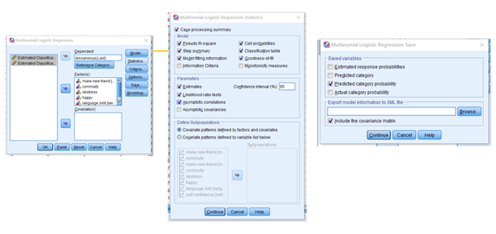

***Figure1. Model parameter configuration***

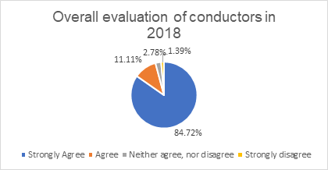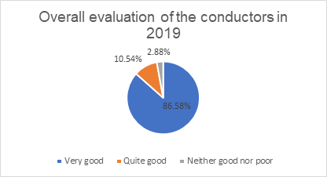

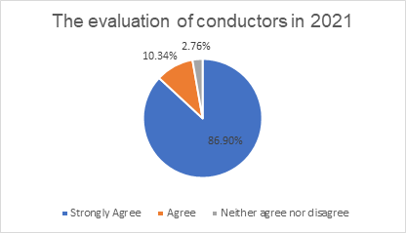

**Figure 2.1a: The evaluation of conductors is in 2018,2019 and 2021**

**Figure 3: Sentiment Analysis using RapidMiner**